**LAB 1**

**EXERCISE**

1. List all files in your home directory, including hidden ones, in the detailed long format with human-readable file sizes.

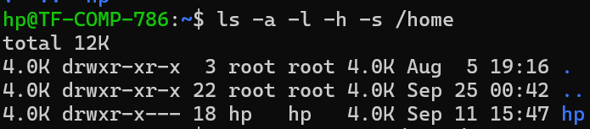

1. Save the list of all executable programs in the /bin directory into a file in your home folder named bin_list.txt.



1. Find all files in the /etc directory that were modified in the last 5 days.

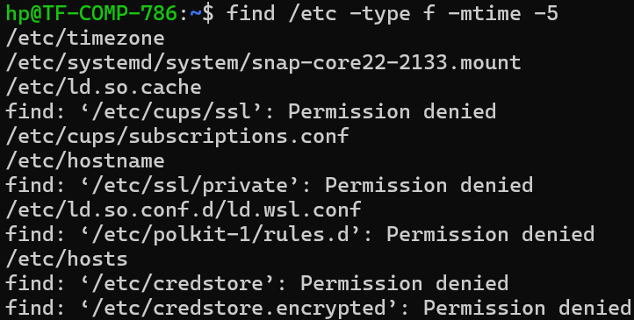

1. Search for your own username within the /etc/passwd file.



1. List all files in the current directory that end with the .conf extension and sort them by size, with the largest file appearing first.

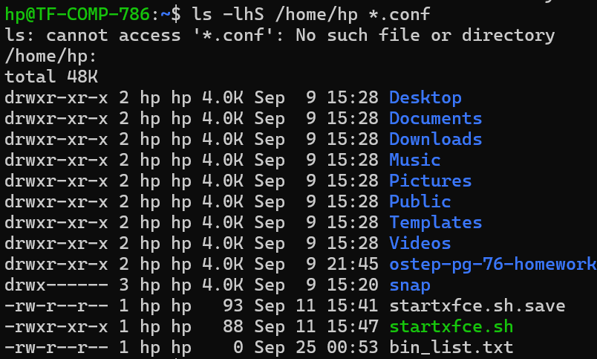

1. Count the total number of files and directories located in your home directory. (Hint: Pipe the output of one command to another).



1. Recursively search the /home directory for any file containing the text "error" (case-insensitive) and display only the names of the files that contain it.

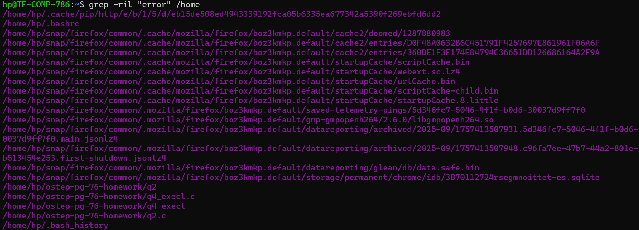

1. Display the first 10 lines of the history command's output. (Hint: You will need to use a pipe and a command like head).

